Course Methods Year 12

Student name: ________________ Teacher name: ________________

Task type: Response

Time allowed for this task: _____45______ mins

Number of questions: _____8______

Materials required: Calculator with CAS capability (to be provided by the student)

Standard items: Pens (blue/black preferred), pencils (including coloured), sharpener, correction fluid/tape, eraser, ruler, highlighters

Special items: Drawing instruments, templates, notes on one unfolded sheet of
A4 paper, and up to three calculators approved for use in the WACE examinations

Marks available: __49____ marks

Task weighting: __10__%

Formula sheet provided: Yes

Note: All part questions worth more than 2 marks require working to obtain full marks.

Q1 (3.1.7) (9 marks)
Use the product rule and/or quotient rule to differentiate the following.(Simplify)
- (3 marks)
Solution
Specific behaviours
demonstrates use of product rule
differentiates correctly
simplifies
NOTE: Zero for answer only as done by classpad

- (3 marks)

Solution

(May leave denominator in expanded form)
Specific behaviours
demonstrates use of quotient rule
differentiates correctly
simplifies
NOTE: Zero for answer only as done by classpad

- (3 marks)

Solution
Specific behaviours
demonstrates use of product and chain rules correctly
differentiates correctly for entire function
Simplifies correctly
NOTE: Zero for answer only as done by classpad

Q2 (3 marks)
Determine the equation of the tangent to at the point .

Solution
Specific behaviours
uses chain rule to differentiate
solves for constant
states equation

Q3 (3.1.8) (8 marks)
Consider the functions and their derivatives with values given for the following x values.
X value | -1 | 3 | 7
 | 5 | 2 | -4
 | 0 | 1 | -2
 | 2 | 5 | -3
 | -1 | -2 | 6

Determine the following derivatives at the given x values.’

- at (2 marks)

Solution
Specific behaviours
uses product rule
states result

- at (3 marks)

Solution
Specific behaviours
demonstrates chain rule
subs values correctly
states final result

- at (3 marks)

Solution
Specific behaviours
demonstrates quotient and chain rule
subs values correctly
states final result

Q4 (3.1.14, 3.1.15) (7 marks)
Use calculus techniques to determine the exact coordinates of any stationary points on the following curves and use the second derivative test to determine the nature of the stationary point.

- (3 marks)

Solution

(4,-1) inflection

Specific behaviours
determines first derivative
equates to zero and solves for stationary pt and states y value
determines value of second derivative and states horizontal inflection

- (4 marks)

Solution
Specific behaviours
determines first derivative and equates to zero
solves for stationary pts including y value
determines second derivative for stationary pts
identifies nature for each stationary point

Q5 (3.1.12) (7 marks)
The displacement of a body from an origin O, at time seconds, is metres
where , .

Determine the following.
- The velocity function. (2 marks)

Solution
Specific behaviours
differentiates
expresses in terms of t

- The times and displacements when the body is at rest. (3 marks)

Solution
Specific behaviours
equate velocity to zero
solves for time
determines displacement

- The distance travelled in the first 12 seconds. (2 marks)

Solution

t=0 x=18

t=5.5 x=-12.25 turns around

t=12 x=30

Distance equals 18 +12.25 +12.25 +30=72.5 metres

Specific behaviours
determines distance from start to turning pt
determines total distance, no need for units.

- and explain its meaning. (2 marks)

Solution

Acceleration of 2 at t=1 second

Specific behaviours
states acceleration at time t=1 (accept rate of change of v at t=1)
states 2 for second derivative

Q6 (3.1.10) (3 marks)
If use the small increments formula to determine the approximate percentage change in when decreases by .

Solution
Specific behaviours
uses increments formula
obtains expression for approx. percentage change for y in terms of x
obtains approx. percentage change for y

Q7 (3.1.11) (6 marks)
A colony of bacteria is represented as a circle on a petri dish and is increasing in such a way that the number of bacteria present is given by where , being the radius of the circle of bacteria.
- Determine and explain its meaning. (3 marks)
Solution

Rate of change of N at x=2 (SCSA preferred answer)

Specific behaviours
states derivative in terms of x
states value at x=2(accept approx.)
describes as rate of change at x=2 (accept gradient of tangent at x=2)

- Determine and explain its meaning. (3 marks)

Solution

Rate of change of at x=2 (SCSA preferred answer)
Specific behaviours
states second derivative in terms of x
states value at x=2(accept approx.)
describes as rate of change of at x=2 (accept gradient of dy/dx at x=2)

Note must mention at x=2 otherwise max 4 out of 6 marks

Q8 (3.1.16) (4 marks)
Consider a closed hollow cylinder with end radius and length .
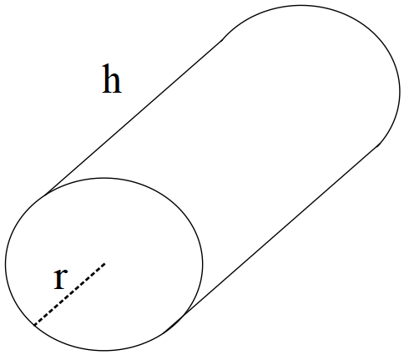

If the outside of the cylinder has a surface area of determine the dimensions of the radius and length, nearest cm, to maximise the capacity of the cylinder using calculus techniques.

Solution
Specific behaviours
states constraint equation in terms of r and h
differentiates V and equates to zero
solves for r and h, must be in decimal form but do not penalise if not rounded to nearest cm
uses second derivative test to show local max

